**ASSIGNMENT -1**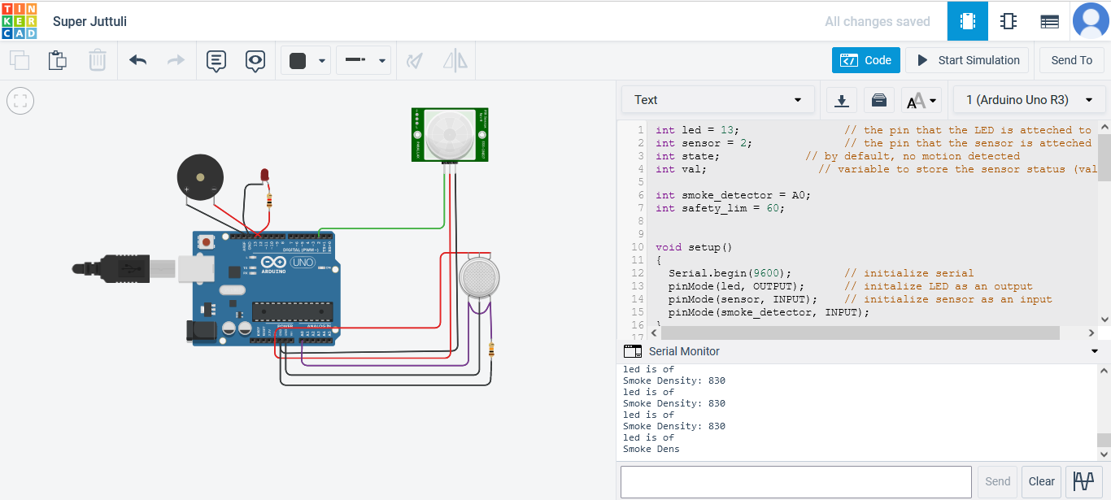

# SUBMITTED BY

# - VARSHA